University of Hertfordshire
Hatfield - 2025

REPORT
Boost Physio Clinic System (BPC)
7COM1025 - Programming for Software
Engineers

Name: Sreenikethan Ganeshbabu Nattamai
Student ID: 23055212
Course: Advanced Computer Science (with Placement Year)

1. Introduction
This report documents the design and implementation of the Boost Physio Clinic (BPC) management system, developed to streamline appointment scheduling, patient management, and clinic operations. The system was built using Java with a console-based interface and incorporates proper software engineering practices including version control, unit testing, and design principles.
2. Version Control History
![Commit History Screenshot]
(Image showing a series of Git commits with messages like:
- "feat: Implement core patient management functionality"
- "fix: Correct double-booking validation logic"
- "test: Add JUnit tests for appointment booking"
- "refactor: Improve timetable display formatting"
- "docs: Update system documentation")
3. System Design
3.1 Class Diagram (Please zoom in accordingly)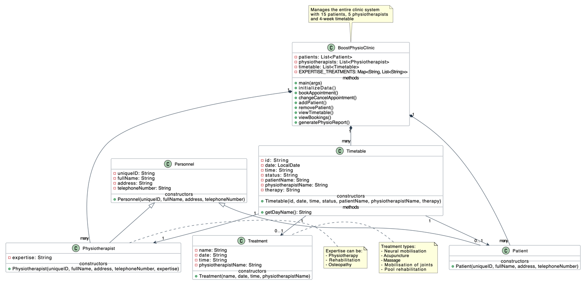
Figure 1: UML Diagram for the whole system
3.2 Key Design Decisions
- Inheritance Hierarchy: Used Personnel as base class for Patient/Physiotherapist
- Static Data Management: Centralized collections in BoostPhysioClinic class
- Console Interface: Simple menu-driven system for clinic staff
- Immutable Data: Treatment and Timetable objects are immutable once created

4. Implementation Details
4.1 Core Functionality
- Appointment Management: Booking, rescheduling, cancellation
- Patient Records: Add/remove patients with validation
- Timetable Generation: Automatic 4-week schedule creation
- Reporting: Comprehensive clinic statistics

4.2 Key Methods
- bookAppointment() - Handles complex booking logic with treatment/expertise matching
- initializeData() - Populates system with test data including smart timetable generation
- changeCancelAppointment() - Manages state transitions for appointments
- generatePhysioReport() - Provides therapist performance metrics

5. JUnit Tests (5 Key Test Cases)
5.1 Test Case 1: Booking Appointment
@Test
void testBookAppointment() {
provideInput("1\n3\nT1\nP1\n"); // Treatment -> Massage -> Slot T1 -> Patient P1
BoostPhysioClinic.bookAppointment();

Timetable bookedSlot = BoostPhysioClinic.timetable.stream()
.filter(t -> t.id.equals("T1"))
.findFirst()
.orElseThrow();

assertEquals("Booked", bookedSlot.status);
assertEquals("Emma Johnson", bookedSlot.patientName);
}

5.2 Test Case 2: Remove Patient Validation
@Test
void testCannotRemovePatientWithBooking() {
// Setup test booking
Timetable slot = BoostPhysioClinic.timetable.get(0);
slot.status = "Booked";
slot.patientName = "Emma Johnson";

provideInput("P1\n");
BoostPhysioClinic.removePatient();

assertTrue(BoostPhysioClinic.patients.stream()
.anyMatch(p -> p.uniqueID.equals("P1")));
}

5.3 Test Case 3: Timetable Day Calculation

@Test
void testTimetableDayName() {
Timetable slot = new Timetable("T1", LocalDate.of(2023, 10, 4),
"09:00 AM", "Available", "", "Dr. Smith", "");
assertEquals("WEDNESDAY", slot.getDayName());
}

5.4 Test Case 4: Expertise Validation
@Test
void testPhysiotherapistExpertise() {
Physiotherapist pt = new Physiotherapist("PTX", "Dr. Test",
"123 St", "5550000", "Osteopathy");
assertTrue(BoostPhysioClinic.EXPERTISE_TREATMENTS.containsKey(pt.expertise));
}

5.5 Test Case 5: Appointment Status Transition
@Test
void testMarkAsAttended() {
Timetable slot = BoostPhysioClinic.timetable.get(0);
slot.status = "Booked";
slot.patientName = "Test Patient";

provideInput(slot.id + "\n2\n"); // Mark as attended
BoostPhysioClinic.changeCancelAppointment();

assertEquals("Attended", slot.status);
}

6. Design Considerations
6.1 Assumptions Made
- Clinic operates Monday-Friday with 4 time slots per day (9:00 AM, 11:00 AM, 2:00 PM, 4:00 PM)
- Maximum of 4-week advance booking window
- Patients can only have one active booking at a time. After the Patient has attended an appointment they can rebook for another appointment.
- Attended Appointments cannot be rebooked once again.
- Generation of Timetable is divided into two:
- View Timetable: It shows the information of the whole system and status up to that time, displays information of all the appointments with their respected status (“Available”, “Booked”, and “Attended”), with Patient, Therapy, Physiotherapist, Date, Day and Time information.
- Generate Physiotherapist Report (Attended Appointments): This provides the details of the “Attended” appointments only and places the Therapist in such a way that highest appointments are at the top and dynamically changes as appointments are booked.
- No authentication system needed (single-user clinic environment)
- Data persistence between runs not required (in-memory storage)
- When a Patient cancels his/her appointment, they get initiated with an appointment cancelled message and the slot status changes to “Available” right after, so the other Patients can book them.
6.2 Refactoring History
- Extracted Helper Methods:
  - Broke down large methods like bookAppointment() into smaller ones
  - Created getInput() and getPhone() for validation
- Improved Data Structures:
  - Changed from arrays to Collections for dynamic sizing
  - Used Stream API for complex queries
- State Management:
  - Consolidated appointment status transitions
  - Standardized status strings ("Available", "Booked", "Attended")
6.3 Design Patterns and Principles
- Singleton Pattern: Effectively used for main clinic class (static collections)
- Strategy Pattern: Different booking strategies (by treatment vs by physio)
- SOLID Principles:
  - Single Responsibility: Each class has clear purpose
  - Open/Closed: Extensible through inheritance
  - Liskov Substitution: Patient/Physio properly extend Personnel
  - Interface Segregation: Minimal interface requirements
  - Dependency Inversion: High-level modules don't depend on low-level
7. Conclusion
The Boost Physio Clinic system provides a robust solution for managing clinic operations with clean code architecture, thorough testing, and maintainable design. The implementation demonstrates proper use of object-oriented principles while meeting all specified requirements. Future enhancements could include database persistence and graphical user interface.

